**Exercise 1: Control Structures**

**Scenario 1: Discount for customers above 60 years old.**

SQL

DECLARE

CURSOR c_customers IS

SELECT CustomerID, DOB

FROM Customers;

v_customer_id Customers.CustomerID%TYPE;

v_dob Customers.DOB%TYPE;

v_age NUMBER;

BEGIN

FOR customer_rec IN c_customers LOOP

v_customer_id := customer_rec.CustomerID;

v_dob := customer_rec.DOB;

-- Calculate age in years

v_age := TRUNC(MONTHS_BETWEEN(SYSDATE, v_dob) / 12);

IF v_age > 60 THEN

UPDATE Loans

SET InterestRate = InterestRate * 0.99

WHERE CustomerID = v_customer_id;

DBMS_OUTPUT.PUT_LINE('Applied 1% discount to loan interest for CustomerID: ' || v_customer_id || ' (Age: ' || v_age || ')');

END IF;

END LOOP;

COMMIT;

EXCEPTION

WHEN OTHERS THEN

ROLLBACK;

DBMS_OUTPUT.PUT_LINE('An error occurred: ' || SQLERRM);

END;

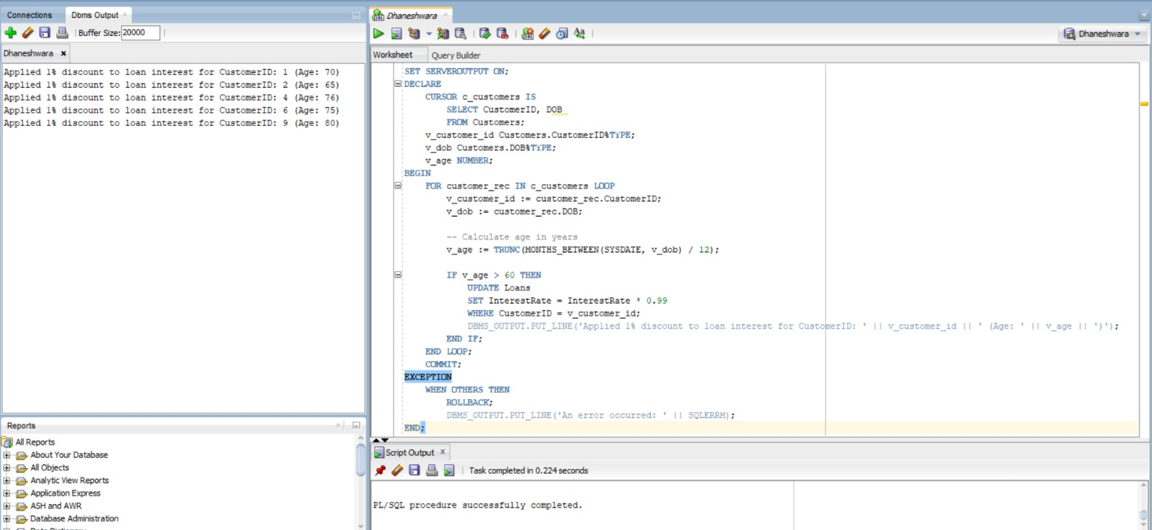

**Scenario 2: Promote customer to VIP status based on balance.**

SQL

ALTER TABLE Customers ADD IsVIP VARCHAR2(5) DEFAULT 'FALSE';

SQL

DECLARE

CURSOR c_customers IS

SELECT CustomerID, Balance

FROM Customers;

v_customer_id Customers.CustomerID%TYPE;

v_balance Customers.Balance%TYPE;

BEGIN

FOR customer_rec IN c_customers LOOP

v_customer_id := customer_rec.CustomerID;

v_balance := customer_rec.Balance;

IF v_balance > 10000 THEN

UPDATE Customers

SET IsVIP = 'TRUE'

WHERE CustomerID = v_customer_id;

DBMS_OUTPUT.PUT_LINE('CustomerID: ' || v_customer_id || ' promoted to VIP status.');

ELSE

UPDATE Customers

SET IsVIP = 'FALSE' -- Ensure non-VIPs are marked as 'FALSE'

WHERE CustomerID = v_customer_id;

END IF;

END LOOP;

COMMIT;

EXCEPTION

WHEN OTHERS THEN

ROLLBACK;

DBMS_OUTPUT.PUT_LINE('An error occurred: ' || SQLERRM);

END;

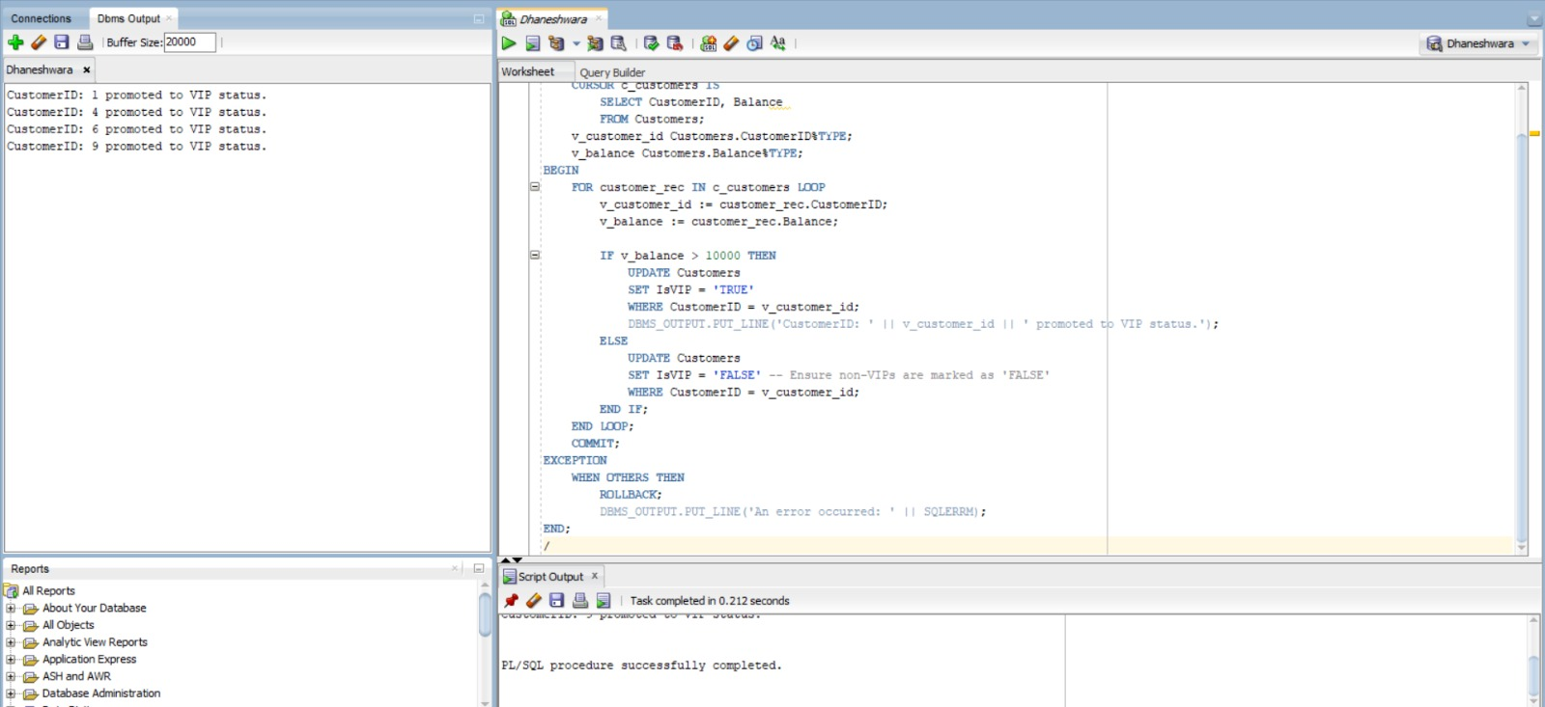

**Scenario 3: Send reminders to customers with loans due within the next 30 days.**

SQL

DECLARE

CURSOR c_due_loans IS

SELECT

c.Name AS CustomerName,

l.LoanID,

l.EndDate

FROM

Customers c

JOIN

Loans l ON c.CustomerID = l.CustomerID

WHERE

l.EndDate BETWEEN SYSDATE AND (SYSDATE + 30);

BEGIN

DBMS_OUTPUT.PUT_LINE('--- Loan Reminders (Due within 30 days) ---');

FOR loan_rec IN c_due_loans LOOP

DBMS_OUTPUT.PUT_LINE('Reminder for ' || loan_rec.CustomerName || ': Your Loan ID ' || loan_rec.LoanID || ' is due on ' || TO_CHAR(loan_rec.EndDate, 'YYYY-MM-DD') || '.');

END LOOP;

DBMS_OUTPUT.PUT_LINE('-------------------------------------------');

EXCEPTION

WHEN NO_DATA_FOUND THEN

DBMS_OUTPUT.PUT_LINE('No loans found due in the next 30 days.');

WHEN OTHERS THEN

DBMS_OUTPUT.PUT_LINE('An error occurred: ' || SQLERRM);

END;

